Design Diagrams
Level 0 shows the simple branch where the phone determines if the call is encrypted or not. If the call is encrypted, the diagram branches to the non-descript task of communicating with encryption.
Level 1 is expanded to show the encrypted/unencrypted conversion branch on both the sending and the receiving phone. Also included is a loop to illustrate the encryption process that occurs on both phones while the conversion is taking place.
Level 2 elaborates on the encryption key exchange process and the conversation encryption process. This diagram also mentions the on-screen indicator to the user warning them that the call will not be encrypted. The names of the processes in the “Both Phones” section describe the conversation process in more detail, stating each step between when the voice data is picked up by the microphone and sent to the antenna.

Conventions Used in Diagrams
In Design Level 1 and Level 2 Diagrams, the phone operations are divided into three groups: “Sending Phone”, “Receiving Phone” and “Both Phones” in order to separate activities that are unique to sender or receiver. The “Both Phones” section contains the process that encrypts the conversation as this is the same for both phones once the conversation has been established.
Several processes are enclosed in Predefined Process nodes in order to keep the phone’s normal operation out of the diagram. The “Continue Call Normally” process, for instance, is there as a place holder for the normal operation of a phone call, without leaving that step in the overall sequence vague.
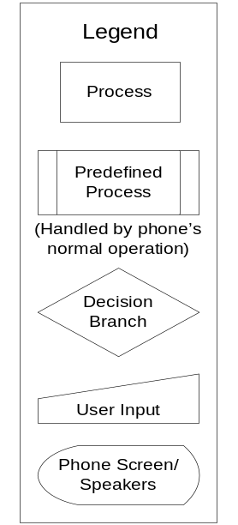
(Refer to the legend for the meaning of node shapes)

